Online Bike Renting System
System Request and Feasibility Study / Planning Phase
(Homework No.1B)

Project team: Team 10
Instructor: Dr. Araz Yusubov

Submitted in partial fulfillment of the requirements of the INFT 2303: Systems Analysis and Design course project.

GitHub repository | https://github.com/ADA-SITE-INFT2303-2023-Spring/sys-dev-project-team-10/
Version date | Version information
24.02.2022 | Initial draft
05.03.2022 | Final paper

Team member | Contribution to this homework (NOT the project) | Estimated %
Afsana Mammadova | Table of contents, overall description, product perspective, organizational feasibility, reference (own reference), introduction (Note: final paper -> combining all parts and submitting) | 32%
Ahmad Huseynli | Introduction, definition, economic feasibility, assumptions and dependencies, reference (own reference) | 36%
Fredasif Maharramli | Product functions, technical feasibility, constraints | 32%
Leyla Novruzova | Not even once joined to the online meetings. We feel sorry for her not to be part of the project! | 0%

Table of Contents
Table of Contents 2
1. Introduction 2
Definitions 2
2. Overall Description 3
Product Perspective 3
Product Functions 4
User Characteristics 5
Constraints 5
Assumptions and Dependencies 6
3. Feasibility Analysis 6
4. References 9

Introduction
This is part of the System Proposal for a hypothetical project Online Bike Renting System submitted for partial fulfillment of the requirements of the Systems Analysis and Design course in the School of Information Technologies and Engineering at ADA University, Baku, Azerbaijan.

Team members:
Ahmad Huseynli – Online Governmental Voting System
Afsana Mammadova - Online Bike Renting System
Fredasif Maharramli – Online Transport Guide
Leyla Novruzova – Online Stray Animal Care

- Online Governmental Voting System – The scope is not big.
- Online Transport Guide – Another team has done this project; therefore, it was not selected.
- Online Stray Animal Care – Leyla did not join to the project selection; we did not understand and compare size, scope, risks and so on with team members.

Online Bike Renting System

Convenience: Online bike rental services provide a practical alternative for customers to rent bikes without having to make a physical trip to a rental business.

Flexibility: Most online bike rental services allow consumers to rent a bike for only a few hours or even for a longer amount of time, giving them more choice in terms of rental duration.

Sustainability: Renting a bike rather than buying one can be more environmentally friendly because it cuts down on the demand for bike production and transportation. Also, a lot of online bike rental services provide eco-friendly bikes or take steps to lessen their influence on the environment.

Definitions

Term | Definition
Net Banking  QR Code (Quick Response Code)  Near Field Communication (NFC)  cloud-based machine learning  Accessibility Index  Intangible benefit  Intangible cost | the system that allows you to put in or take out money from a bank account by using the internet.  a pattern of black and white squares that can be read by a smart phone, allowing the phone user to get more information about something.  a short-range wireless connectivity technology that uses magnetic field induction to enable communication between devices when they're touched together or brought within a few centimeters of each other.  provides optimized AI services for use cases like computer vision, natural language processing, speech synthesis, and predictive analytics.  a measure that provides an indicator of accessibility and density of the public transport networks for an individual home.  a more subjective benefit that you can't actually touch and is difficult to measure in dollar terms.  a cost that can be identified but cannot be quantified or easily estimated.

Overall Description

Now a day’s Baku transportation is full of crowdedness and traffic jams. Buses and metro are full of people which results in an uncomfortable trip. If they use a car or taxi, then very high possibility is losing time on the roads. Baku need fresh new transit that can give people another option for traveling inside the city. Bicycles are no longer just a means of transportation for athletes; they can now be available at a number of convenient locations that are also accessible to pedestrians around the world. It is anticipated that this study will enable the development of a computerized, dependable bicycle rental system that can handle simple, quick, and secure payment transactions without the need of cash in Baku. When clients are registered members on this system customers will be able to search for and rent bikes. They can view and manage their profile. It is a system where system administrators can control every component. People will also have a customer subscription which will contribute to reaching new revenue to our profit. Moreover, by 2027, the rental market for bicycles and scooters is expected to increase by more than 400% and reach $10.1 billion. The goal is to create a system that is secure and void of bugs.

From the research done on ADA students, it is obvious that no one uses bikes because they don’t have bikes or there is no option for renting. However, they would be happy to ride bikes if Baku was a bike-friendly city.

Product Perspective

In Baku, you can ride bikes in Sahil Bulvari for only joy and you can rent them for 1 or 2 hours. Then you need to bring the bikes where you take them. It means bikes are not means of transportation. In addition, this process happens manually not through an Information System. You go to the bike area; you must pay there to get bikes and in return, they take your ID cards.
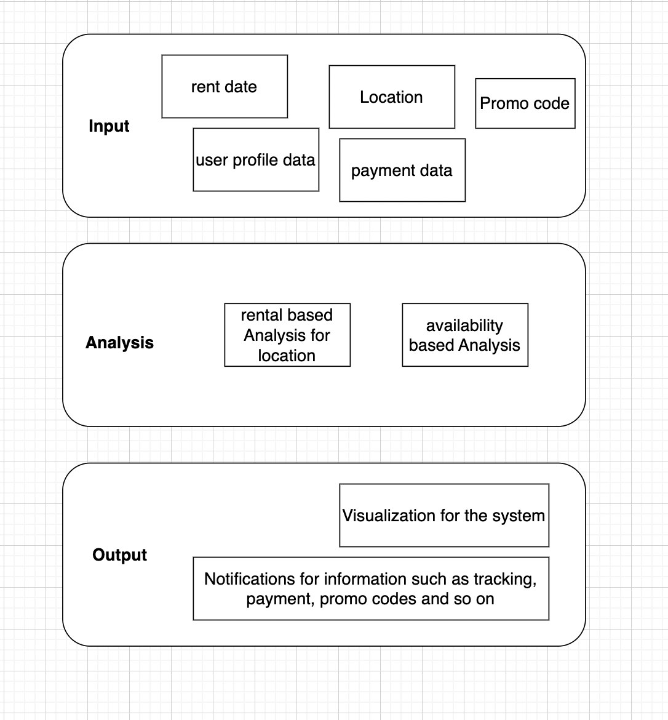

Our system will be computerized, people will be able to rent the bikes around scanning QR. In the application, they will create a profile for themselves, enter their card info and then rent the bikes without any issue with this app.

Product Functions

People will be able to get bicycles at any time and from any place in the city. The bicycles will come from a factory in Ismayilli (Isma Bikes). The system will do the following things most often:

- Bicycle Rental: The system will let people rent bikes from parking lots, universities, and workplaces in and around Baku.

- Bike Availability: The system will show where bikes are available on a map, making it easy for users to find the closest place to rent a bike.

- Signing up as a user: To use the app, users will sign up with personal information, which will be saved in the system.

- User Profile: Users will be able to set up and manage their profiles, which will include payment options.

- Tracking bikes: The system will keep track of the rented bikes to make sure they are safe and stop them from being stolen.

- Friend Tracking: The system will let people find out where their friends are and ride with them.

- Payment Options: The app will give you different ways to pay for renting a bike, like using a credit card or your phone. Add NFC method

- Promotions: The system will offer users special deals and discounts to get them to use the service more often.

- Bike Parking Tracking: The app will track where rented bikes are parked to ensure they are returned to the right place.

The functions will be set up to make it easy for customers or anyone reading the document for the first time to understand them. Graphs may be used to show the logical connections between variables. The method will also be repeated, and the features may change and get better over time. The system should be user-friendly and accessible to individuals of all ages and levels of technological expertise. It should also be secure and dependable to provide users with a safe and hassle-free bike rental experience.

User Characteristics
The user, who is a client, may view all of the bikes that are available for hire.
- Registration:
- User Registration
- Vehicle Registration
- Renting Operation
- Renting Cancellation.
- Renting Confirmation.
- Renting Details
- Online Renting
- Manual renting
- Search
- Vehicles Catalogues Available bikes
- Booking
- Search Car

Bike: In order to prevent other customers from trying to reserve the same bike, the status of the vehicles can be updated as soon as they become available or booked. The model number, vehicle number, and owner name are the details that are applied to a bike.

Payment: As the money paid through this system goes to the admin, who can then pay all the event managers in accordance with their work, this module is provided so that clients may quickly pay the amount. The consumer has three payment options: debit card, credit card, and net banking.

Constraints
- People's mindsets: As previously said, a developer's options may be constrained by people's mindsets. Promoting biking as an alternate mode of transportation might be challenging because many individuals buy vehicles as a sign of social status. This constraint can necessitate the developer to use pricey and time-consuming marketing techniques to alter people's perceptions.

- Bike maintenance and repairs are yet additional restrictions that designers must consider. The availability of motorcycles for users may be restricted by the need for maintenance and repairs on bikes. To avoid causing users any hardship, developers must make sure there are enough bikes accessible and that they are properly maintained. The developer may also incur fees as a result of repairs and upkeep.
- Infrastructure constraints: Azerbaijan lacks the necessary infrastructure, such as designated bike lanes, bike racks, and charging stations, to facilitate the widespread use of bicycles, developer should consider these restrictions and offer suitable solutions that function with the current infrastructure.
- There may be locations in Azerbaijan with poor internet connections, which could limit the system's ability to deliver real-time updates or necessitate that users have a stable internet connection to utilize the system. Users who might not have a dependable internet connection should be given other options by the system, which should consider these connectivity restrictions.

- Environmental restrictions: Due to Azerbaijan's diverse geography and climate, the system may not be able to deliver bicycles to all locations or at all times of the year. The system should consider these environmental restrictions and offer suitable solutions that comply with them.
6. Financial constraints: For developers, the cost of creating and maintaining an online bike rental system might be a major barrier. Hardware, software, labor costs, and other costs related to the system's operation must all be taken into account while designing the system to be cost-effective.
These are just a few examples of the constraints that may apply to an online bicycle-renting system.

Assumptions and Dependencies

Assumptions:

- Self-sustainable transport circuit: To guarantee that cycles go smoothly from dock to dock, extensive design and thoughtful dock placement are required.
- Navigation support: It's tough for the user to ride a bicycle and use a phone to check the map while glancing down at the handlebar display module for navigation. So, a display module that can convey directions like "Turn left!" may be placed into the handlebar.
- Using mobile password to securely lock and unlock the rented bikes: During the onboarding process, customers can use security commands like codes to match the bike and smartphone. As it might be challenging for the user to scan QR codes in dim light, this will be preferable to doing so.

Dependencies:
- Using Near Field Communication (NFC), the smartphone and bicycle can have a communication link. For an alternative, user voice recognition or scanning QR codes can be utilized if the mentioned module is not possible.
- A cloud-based machine learning method that assesses bicycle availability and generates the Accessibility Index.

Feasibility Analysis

Technical feasibility: can we build it?

To assure the technological viability of our bike rental system, we require professional developers and designers to create a bike rental application. The program must be compatible with all operating systems, including iOS and Android, in addition to utility bill payment systems. We used languages such as JavaScript, MySQL, HTML, CSS, and PHP in addition to the necessary hardware and software to construct the system.

Hardware | Laptop, GB RAM, 500 GB HDD
Software | PHP Strom, Mc Office, Operating systems, JavaScript

Economic feasibility: should we build it?
Considerations for economic viability include the project budget, the cost of the equipment, the cost of the personnel, and the project's maintenance costs. The most crucial component of a project is the budget. This section considers it to be extremely significant.

- Development costs

The features and development you choose is one of the main factors that determine the price of your cycle rent app. Additionally, where the development team is located can also affect the cost.

Apps that help people rent bikes don't need a lot of features, because their main purpose is to help people find and rent bikes. A minimal viable product (MVP) - a version of the app with just the basics - costs around $30,000.

A project can cost up to $100,000, but it might also cost more depending on the development company you choose.

- Annual operating costs

The cost-benefit analysis is an important part of any project. By doing this, you'll be able to compare the total cost of the project with the potential earnings from the project. This will help you decide whether the project is worth doing. The information is included about the cost of the project and the potential benefits of the project.

Costs:
- Software | 1000 $
- Hardware | 2500 $
- Hosting Cost via Web | 150 $
- Wi-Fi Routers | 150 $
- Computers | 2500 $
- Microsoft Office | 22 $/ month
- PHP Strom IDE by Jetbrains | 250 $
- Adobe Creative Cloud | 54.99$/month
- Adobe XD | 9,99$/month
- Others | 230 $
TOTAL | 6780 $  86.98$/month

- Annual benefits (cost savings and/or increased revenues)
- Business income | 1500 $
- Booking / renting | 2500 $
- Financial gain | 3500 $
TOTAL | 7500 $

- Intangible benefits and costs

Intangible Benefits | Intangible Costs
Flexibility of usage since you can hire a bike for as long as you need it without committing to purchase. | The initial cost of purchasing one.
Several bike types are available. | Enduring dedication.
No responsibility for upkeep or repairs. | There is no way to modify the bike to user’s tastes.
Cost-efficient choice. | Helmet use is required. It is imperative to wear a helmet. Certain bike sharing programs might not supply them.
With several pick-up and drop-off points across the city, it is practical. | Overload Among Bike Sharing Users. If the bike is unavailable, waiting might be inconvenient. This issue could arise during rush hour.
A more flexible and practical alternative to typical bike rentals. | Limited Availability during inclement weather conditions, which may restrict usage of the bike rental system.
The bicycle rental system will automatically track the employees' timesheets, and user will have easy access to them no matter where they are.
Healthy traveling method.
Easily accessible kind of transportation.
Environmental advantages to nature.

- Necessary calculations

According to the European Commission (1999), bicycles are a reliable mode of public transit for distances of 2 to 8 minutes.
Also, according to the Metropolitan Washington Council of Governments (2010), the average riding speed is 15 km/h. As a result, the typical riding distance is between 0.5 and 2 kilometers. In this research, the maximum distance between two bicycle rental stations will be 12 km, or four times 2 km.

According to Commins and Nolan's (2011) study on Dublin, Ireland, 3.5% of people who are 15 years old or older use bicycles on a regular basis. 2.2% of people in Taichung, Taiwan, who are 15 or older use bicycles for everyday transportation. According to Lusk et al. (2014), 31.7% of female bicycle riders and 30.9% of male bicycle users, respectively, will hire public bicycles. Based on the aforementioned data, the demand for each bicycle rental station will be calculated as 0.6%, or 2.2%* (30.9% + 31.7%/2), of the population that is 15 years of age or older.

According to information from the Taipei City government, each bicycle requires 52 m2 (26 m long by 2 m wide), hence for the sake of this study, the land need will be set at 2 m2.
The majority of the bicycle rental shops are situated near subway stations in Taipei City's early stages of development, making it simple to connect to other public transit options. This idea will be put into practice in Taichung City, which will serve as the research's case study.

Organizational feasibility: if we build it, will they come?
The organizational feasibility evaluation reveals significant risks, thus the team members should take measures like developing a system prototype to show off its potential value, encouraging consumers to accept and utilize the system, periodically seeking user feedback, and so on. The idea has the support of the company's top executives, and its champion is a reputable and experienced Baku Transport Agency. The system's users are expected to welcome the vast number of bikes entering the urban region. Although management on the streets may be concerned about lost or damaged bikes, it could possibly be avoided because the system provides bike security and repair management. Therefore, the system can prevent losing those customers to other transits.

References
- Hana Ayedi, Alaeddine Zouari, Nadia Hamani. An exploratory study of the bike rental system in Sfax -Tunisia. International Conference on Advanced Logistics and Transport (ICALT) 7th IEEE 2019, Jun 2019, Marrakech, Morocco. ⟨hal-02425222⟩
- Billhardt H, Fernández A, Ossowski S. Smart Recommendations for Renting Bikes in Bike-Sharing Systems. Applied Sciences. 2021; 11(20):9654. https://doi.org/10.3390/app11209654
- Macioszek, Elżbieta & Świerk, Paulina & Wyderka, Agata. (2020). The Bike-Sharing System as an Element of Enhancing Sustainable Mobility—A Case Study based on a City in Poland. Sustainability. 12. 3285. 10.3390/su12083285.
- Journal of Innovative Technology, Vol. 1, No. 1, pp. 13-20, March 2019
http://doi.org/10.29424/JIT.201903_1(1).0002
- SHIVARAJ KUMAR T H, et. al. "Online Car/Bike Rental Management System.” International Journal of Engineering Science Invention (IJESI), Vol. 11(07), 2022, PP 22-25. Journal DOI10.35629/6734
- https://pedalergripcovers.com/blogs/gottapedal/bike-sharing-systems
- https://rentrax.com/why-use-bike-rental-software/
- https://medium.com/urbansharing/the-economic-benefits-of-bike-sharing-f69c230e5a9d
- https://stepbystepbusiness.com/business-ideas/start-a-bike-rental-business/

Note: All references are used by all the members

https://stepbystepbusiness.com/business-ideas/start-a-bike-rental-business/
Reference №5
https://pedalergripcovers.com/blogs/gottapedal/bike-sharing-systems

